Just Noticable Difference Test for Equalizer Peak Filters
Version 1.0.0

Welcome
Thank you for downloading this application. Just Noticable Difference Test for Equalizer Peak Filters determines the just noticeable difference for hearing changes in peak filters.
In order to get the most out of the Just Noticable Difference Test for Equalizer Peak Filters, please spend a few moments reading this brief manual.

License
The pre-compiled Just Noticable Difference Test for Equalizer Peak Filters has a very simple license:

- Just Noticable Difference Test for Equalizer Peak Filters is freeware. This means that you are free to use this program in any context. Also you are free to share it on a personal base (ie. give it to friends). However, only the entire unaltered archive, including this document, may be shared. Public redistribution is only allowed on request.
- Copyright of the code and the pre-compiled plug-in remain property of the Delphi ASIO & VST Project and namely Christian-W. Budde.
- This plug-in is provided at no cost; therefore the author Christian-W. Budde assume no responsibility for any negative effects that may occur to the end user or the equipment used to run the software.
- Magazine editors are welcome to include the plug-in on cover mount discs or similar media; However, it is mandatory to inform the author Christian-W. Budde about this. A copy of the publication is always appreciated, but not expected.

Purpose
The purpose of this tool is to find the just noticeable difference for EQ filters. In version 1.0 only one test has been defined to test the just noticeable gain difference for a peak EQ filter at a frequency of 1 kHz and a bandwidth of 1 octave.
It is subject of scientific research to find the minimum detectable difference of the human ear. However, since hearing has a very complex nature a conclusion can not be made a priori. Especially since not only physical aspects are relevant, but also psychological aspects. In particular an experienced listener is supposed to perform the test with better results.
Apart from the scientific research this tool might be useful to train your ears especially in this regards. Though the test can be performed without this tool, it allows the user to perform a double blind test, where cheating is hardly possible. Especially subconscious cheating might be present if a priori information about the given test are known.

Usage
The application is kept as simple as possible. The start appearance only contains a simple play/pause button to start a pre defined Pink Noise. However, any other MP3 file can be used for the test by double clicking on the label. Using music as excitation signal might either work better or worse depending on your background and experience. Untrained persons voted pink noise to be the easiest as it represents a more or less static signal.
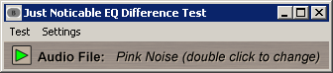
If you don't hear anything by pressing the play button, make sure the audio settings are correct. These can be found under Settings->Audio. So far only ASIO is supported for the lowest latency between switching of the presented alternatives. As default the ASIO4ALL driver is loaded. This driver allows you to use the program on nearly any computer. It can be downloaded here: http://www.asio4all.com
Once a signal is audible, the test can be started via the main menu by clicking: Test->Start

Tests
Currently there is only one test predefined in two modes. By clicking in the main menu: Test->Start the 'full' tests is started. However, also a 'training' mode is available that gives you access to further parameters such as filter frequency and bandwidth.
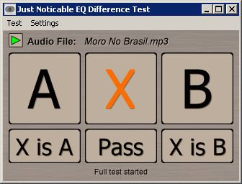
The test itself is a modified ABX test, where all you need to do is to identify if the 'X' is either 'A' or 'B'. To make your choice you can switch neatlessly between 'A', 'B' and 'X' by clicking on the according button.
Once you are sure, click 'X is A' or 'X is B' to continue with the test. If you can not decide at all you 'Pass' this trial. According to your decision and to the history of your decisions a new trial is created until you have done 20 trials.
Once the test is over, a simple survey is presented. You may optionally fill this form before continuing by clicking 'OK'.
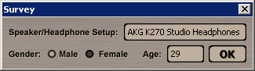
As soon as the survey is closed, the test results are sealed and stored on the hard disc. If available a main in your default email program is created to send the result data for further evaluation. Only relevant information are stored and send to ensure the test is valid.

Feedback / Bug Reports
I am always eager to hear feedback or have bugs reported. The easiest way is to send me a mail to: Christian@aixcoustic.com
Furthermore feel free to download the source code, that can be found in the Delphi ASIO & VST Project at sourceforge.net.

Version History
  - First release!

Credits
• Programming: Christian W. Budde
• Additional Framework Programming: Tobias Fleischer, Maik Menz
• Special Thanks: Swen Müller, Duncan Parsons, Laurent de Soras
• Documentation based on a template by Greg Pettit

VST name and technology © Steinberg GmbH
The VST logo is a trademark of Steinberg GmbH

